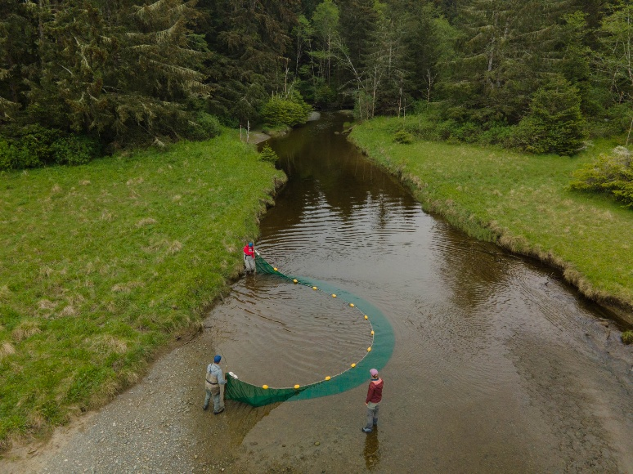
The Salmon Watersheds Lab—led by Dr. Jon Moore at Simon Fraser University—is seeking an USRA summer field researcher to join their Estuary Resilience (ER) project field team. The ER project is a large collaborative effort led by the Nature Trust of BC, in partnership with our lab, several coastal First Nations, and other organizations that aims to increase the resilience of estuary habitats for fish and wildlife along the BC coastline given oncoming climate change. Our lab has led a fish and habitat monitoring program across estuaries on Vancouver Island for the past five years, and will be continuing work this coming summer.
The USRA program (NSERC USRA for Canadian citizens and permanent residents; VPRA USRA for international students) provides 16 weeks of support for the successful applicant to gain research experience.
We are seeking a motivated, hard-working student to assist with field work between late April-June, 2026. This summer, our monitoring program will focus primarily on estuarine bird community surveys, but may also include fish work. We will be working collaboratively with First Nations partners for the field work. During the field season, the student will be expected to travel with the field crew across Vancouver Island (all accommodations and food covered) for up to multiple weeks at a time. The student will participate in data collection, gear preparation and cleaning, and will be expected to help with meal prep and other team work requirements. Data collection will involve long hours and start times as early as 4 am. Field work may include point count or transect surveys to identify birds, setting up automatic recording units, and seine net surveys for fish identification. Previous bird identification experience would be a major asset. Following the field season, the student will be expected to help with data cleaning and analysis; depending on student interest, there may be opportunities to help write up the findings for publications or tackle a side project.
If interested, please send an email to PhD student and ER field lead Lili Simon (lili_simon@sfu.ca) with your CV attached. In your email, please briefly describe your interest in the project and relevant experience. If selected, you will need to then apply for the NSERC-USRA position with our lab.
Step 1. Apply by Jan 28, 2026 to Lili Simon.
Step 2. If selected, apply to the USRA (NSERC or VPRI) by Feb 12, 2026.
https://www.sfu.ca/biology/undergrad/current/financial-aid/USRA-ugrad.html

